**Heirarchy in EIA**

In the hierarchy of Environmental Impact Assessment (EIA) studies, there are four main categories:

1. **Site Selection Studies**: These helps choose the best location for a project by looking at environmental factors.
2. **Rapid or Comprehensive Studies**: Rapid studies are quick, taking 3 months, while comprehensive studies last 9 months. Rapid ones are used when we already know a lot about the project's impacts, and they help identify issues for the comprehensive study.
3. **Regional Studies**: These focus on a whole area, like a region, and check how the environment can handle development.
4. **Carrying Capacity Studies**: These go even bigger, looking at how an area can support development by considering things like resources, infrastructure, and environmental limits.

These types of studies help make sure the EIA fits the project and its impact, whether it's a small site or a big region.

**Purposes of EIA**

Environmental Impact Assessment (EIA) serves three key purposes:

1. **Informed Decision-Making**: EIA informs decision-makers about environmental effects and alternatives, aiding in well-informed choices.
2. **Development Support**: It assists developers in planning projects with minimal environmental impact, fostering better relations with authorities and communities, and streamlining the planning process.
3. **Sustainable Development**: EIA is an essential tool for achieving sustainability, encompassing the quality of life, resource access, and environmental preservation, especially vital in regions facing environmental challenges, including developing countries.

**Benefits of EIA**

Environmental Impact Assessment (EIA) offers various benefits, including:

**For Project Sponsors:**

1. **Efficiency:** EIA reduces project implementation time and costs.
2. **Design Improvements:** It allows for cost-saving modifications in project design.
3. **Acceptance:** EIA increases project acceptance by addressing environmental concerns.
4. **Compliance:** Helps avoid impacts and violations of laws and regulations.
5. **Performance:** Improves overall project performance.
6. **Cost Savings:** Avoids treatment and cleanup costs associated with environmental damage.

**For Local Communities:**

1. **Healthier Environment**: EIA contributes to a healthier local environment, benefiting forests, water sources, agriculture, recreation, aesthetics, and urban living.
2. **Human Health:** Improved environmental conditions lead to better human health.
3. **Biodiversity:** EIA helps in maintaining biodiversity.
4. **Resource Conservation**: Promotes decreased resource use.
5. **Conflict Reduction**: Fewer conflicts arise over natural resource use.
6. **Community Development:** Enhances community skills, knowledge, and pride.

**Stakeholders role in EIA**

Stakeholders play various essential roles in the Environmental Impact Assessment (EIA) process, contributing to its effectiveness and transparency. Here are the key roles of stakeholders in EIA:

1. **Project Proponents/Developers**: They initiate the EIA process and provide information about the proposed project, including its design, potential impacts, and mitigation measures. Their role is to ensure compliance with environmental regulations and facilitate the assessment.
2. **Regulatory Authorities**: Government agencies oversee the EIA process, review assessment reports, and make decisions based on the findings. They ensure that projects meet environmental standards and legal requirements.
3. **Environmental Consultants**: These experts conduct the EIA studies, assess potential environmental impacts, and provide recommendations for mitigation and management. They play a critical role in providing objective assessments.
4. **NGOs**: Monitor EIA for transparency, advocate environmental protection, and represent community interests.
5. **Public**: Provide input in public consultations, ensuring comprehensive impact assessment.
6. **Financiers/Investors**: Assess EIA reports for environmental and financial risks before funding.
7. **Legal Experts**: Ensure EIA compliance with environmental laws.
8. **Local Authorities**: Contribute input and oversight to protect local interests.

**Public hearing in EIA**

Public hearings in Environmental Impact Assessment (EIA) are essential components of the process, serving to promote transparency and public participation. Here's a brief overview:

1. **Purpose:** Public hearings allow the public to voice concerns and suggestions about a proposed project's environmental impact.
2. **Notification:** Public is informed of the hearing's details, including date, time, location, and project information.
3. **Information Sharing:** Project proponents present project details and potential impacts during the hearing.
4. **Public Input:** Attendees, including experts and community members, can ask questions and express their views.
5. **Recorded Feedback:** Comments and feedback are documented and become part of the official EIA record.
6. **Decision-Making:** Public input influences project approval, rejection, or conditions.
7. **Transparency:** Public hearings ensure transparency by involving the community in the decision-making process.
8. **Legal Requirement:** Public hearings are legally mandated for certain projects with significant environmental impacts.

**Steps of EIA (8 marks)**

The Environmental Impact Assessment (EIA) process is a proactive approach to evaluating the environmental consequences of development actions. It involves several key steps:

1. **Project Screening**: Assessing which projects need environmental impact assessment (EIA) based on potential significant environmental effects and regulatory requirements.
2. **Scoping:** Identifying and prioritizing key environmental issues and alternatives early in the assessment process.
3. **Consideration of Alternatives:** Ensuring that different feasible approaches and options, such as project location or scale, are thoroughly examined.
4. **Description of the Project**: Providing a clear and detailed overview of the project's purpose, characteristics, and development stages.
5. **Description of the Environmental Baseline**: Establishing the current and future environmental conditions without the project, considering natural changes and human activities.
6. **Identification of Key Impacts**: Identifying all significant environmental consequences, both positive and negative.
7. **Prediction of Impacts:** Estimating the scale of environmental changes that will occur if the project proceeds.
8. **Evaluation and Assessment of Significance:** Assessing the importance of predicted impacts based on their consequences and likelihood.
9. **Mitigation:** Implementing measures to prevent, minimize, or offset significant adverse impacts on the environment.
10. **Public Consultation and Participation:** Engaging the public to gather input, ensuring a comprehensive assessment, and addressing concerns.
11. **EIS Presentation:** Effectively communicating assessment findings in the Environmental Impact Statement (EIS) to stakeholders and decision-makers.
12. **Review:** Evaluating the quality and completeness of the EIS as a basis for informed decision-making.
13. **Decision-Making:** Authorities use the EIS, public input, and other relevant information to decide whether to approve, delay, or reject the project.
14. **Post-Decision Monitoring:** Recording and managing environmental impacts that occur after project approval to ensure compliance and address issues.
15. **Auditing:** Comparing actual project outcomes with predictions and mitigation measures to assess the accuracy of assessments and improve future EIAs.

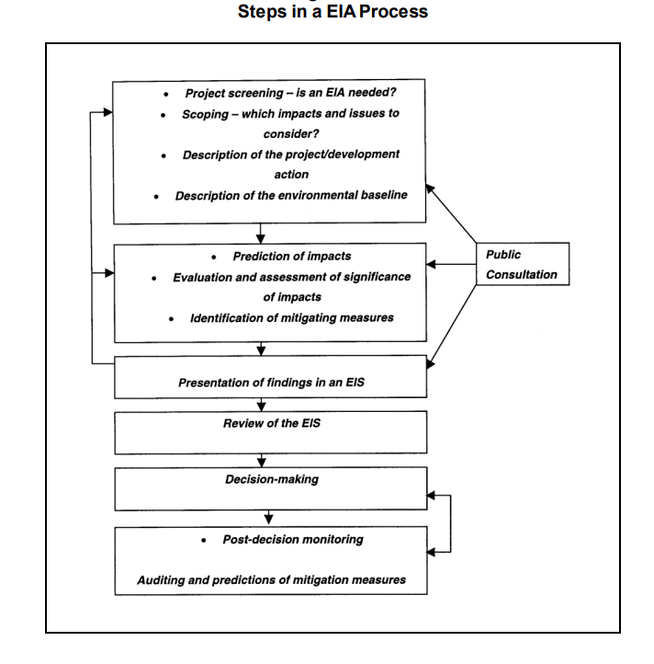

**MOEF Notifications**

* MOEF stands for the Ministry of Environment, Forest and Climate Change in India.
* MOEF issues notifications related to Environmental Impact Assessment (EIA) to provide guidelines and regulations.
* These notifications outline procedures, criteria, and requirements for conducting EIA studies.
* They specify which projects require mandatory EIA studies and the scope of these studies.
* MOEF notifications also detail the public consultation process and the authority responsible for granting environmental clearances.
* These notifications may change over time to align with environmental protection goals and legal requirements.

MOEF notifications regarding Environmental Impact Assessment (EIA) in India serve several key purposes:

1. **Project Classification:** They categorize projects based on their potential environmental impact.
2. **Clearance Process:** Notifications define the steps involved in obtaining environmental clearance, including screening, scoping, and public consultation.
3. **Public Participation:** Public consultation is mandated for certain projects to gather input and address concerns.
4. **Monitoring and Compliance:** Clearances often include conditions for monitoring and compliance with environmental safeguards.
5. **Amendments:** MOEF may update notifications to align with changing environmental regulations.
6. **Penalties:** Violations of environmental regulations may incur penalties.
7. **Regional Considerations:** Specific requirements or variations may apply to different regions or ecologically sensitive areas.